COVID-19 Clinical Research SOPs

TABLE OF CONTENTS

REMOTE WORKING 2
SITE SHUTDOWN 3
STUDY RELATED PROTOCOLS 4
Coordinators 4
Labtech 4
Monitoring 4
SUBJECT PRE-VISIT SCREENING 5
DISEASE SAFETY 6
Cleaning 6
Prevention 6-7
Signs and Symptoms 7
APPENDIX 8
Resources 8
Proper Hand Washing Technique 9

REMOTE WORKING
- Set up remote access if applicable; ensure access to any/all necessary drives
- Keep your work schedule up to date. This includes noting when you are working and at which location, if other than the main office. Take any physical items that you would need in order to work remotely (no patient files may be taken home).
- You may have to allow business calls on your personal cell phone.
- You will be required to have access to WIFI and a compatible computer. If this is not an option you will not be able to work from home.
- Email your monitors that you will be working from home and that they will need to email you or call your cell phone if needed.
- Enter hours into your work calendar. If work hours do not meet 40 hours/week, PTO will be used to cover the difference.
- People working from home need to be available by phone and email in a way they would be if they were physically present. Emails and daily work will need to be completed in the same fashion as if you were at the main office.
- Staff that do not have the availability to work from a remote area will not take after hours calls. These calls will need to be sent to staff that can work remote only.

SITE SHUTDOWN

In the event of a total site shutdown:

- Staff will be assigned to call all subjects and reschedule accordingly. Each subject will be reviewed and follow up will be completed per sponsor guidance.
- Temperatures will be monitored electronically daily. If a temperature excursion occurs, management will notify the sponsor of excursion.
- All monitors will be contacted and notified that we have been quarantined. We will follow the guidelines per individual sponsor. We are willing to do home visits, ship medications to subjects, or continue follow-up as requested within responsible guidelines.

STUDY RELATED PROTOCOLS

Coordinators

- Check with sponsor for any changes that may occur due to pandemic planning, e.g extended visit windows
- Call all subjects the day prior to their visit to ask COVID-19 screening questions
- Check with sponsors to determine if out of window visits are acceptable
- Check with the sponsor to determine if it is possible to issue more than one round of medications for study.
- All SQVs and SIV should be scheduled via phone or web to accommodate remote working and/or limited visitors to the office.

Labtech

- Inventory for all study supplies. Order more if needed
- Confirm contact information on equipment repair if needed.
- Check with sponsor to see if any stored samples can be sent now while site is still at full staff
- Check with external labs to determine their pandemic plans and how the site will be notified if restrictions are put in place.

Monitoring
- Email all monitors to encourage remote monitor visits.

SUBJECT PRE-VISIT SCREENING
All subjects will be called for a reminder call before their appointment. The subject will be asked if they traveled to high infected areas or have any of the symptoms as described below:
- Fever
- Lethargy
- Dry cough.
- Aches and pains
- Nasal congestion
- Sore throat.
If the subject confirms any of these symptoms, their appointment will be rescheduled for a date after the subject has been evaluated by their PCP and confirmed not to have the virus. If the subject has traveled to any of the high infected areas, the subject will be rescheduled until no symptoms or 14 days after travel whichever is greater. If the subject's visit will be out of window, a coordinator should contact their monitor for guidance.
All subjects will be asked upon entering the clinic if they have any of the symptoms described above and/or traveled to high infected areas. If the subject confirms any of these symptoms, their appointment will be rescheduled until the subject has been evaluated by their PCP and confirmed dnot to have the virus. If the subject has traveled to the high infected areas the subject will be rescheduled until no symptoms or 14 days after travel whichever is greater. If the subject’s visit will be out of window, a coordinator should contact their monitor for guidance.

DISEASE SAFETY

Cleaning
This must be completed daily
- Clean and wipe down your workspace
- Get rid of sponges and towels: These are a harbor for viruses and encourage transmission from person to person.
- Increase the frequency of cleaning, especially of common fomites like door knobs, elevator buttons, and water taps. Anything people touch should be cleaned multiple times per day.
- Encourage employees to bring their own utensils: If your office doesn’t have a dishwasher, utensils are a particularly virulent way to spread illness. Ask employees to bring their own
- Educate staff and subjects on proper handwashing techniques (appendix B) and coughing techniques (prevention section)

Prevention
The best way to prevent illness is to avoid being exposed to this virus. However, as a reminder, CDC always recommends everyday preventive actions to help prevent the spread of respiratory diseases, including:
- Avoid close contact with people who are sick.
- Avoid touching your eyes, nose, and mouth.
- Stay home when you are sick.
- Cover your cough or sneeze with a tissue, then throw the tissue in the trash.
- Clean and disinfect frequently touched objects and surfaces using a regular household cleaning spray or wipe.
- Follow CDC’s recommendations for using a facemask.
  - CDC does not recommend that people who are well wear a facemask to protect themselves from respiratory diseases, including COVID-19.
  - Facemasks should be used by people who show symptoms of COVID-19 to help prevent the spread of the disease to others. The use of facemasks is also crucial for health workers and people who are taking care of someone in close settings (at home or in a healthcare facility).
- Wash your hands often with soap and water for at least 20 seconds, especially after going to the bathroom; before eating; and after blowing your nose, coughing, or sneezing.
  - If soap and water are not readily available, use an alcohol-based hand sanitizer with at least 60% alcohol. Always wash hands with soap and water if hands are visibly dirty.
Hygiene etiquette involves practices that prevent the spread of illness and disease. A critical time to practice good hygiene etiquette is when you are sick, especially when coughing or sneezing. Serious respiratory illnesses like influenza, respiratory syncytial virus (RSV), whooping cough, and severe acute respiratory syndrome (SARS) are spread by:
- Coughing or sneezing
- Unclean hands
  - Touching your face after touching contaminated objects
  - Touching objects after contaminating your hands
Cough etiquette is especially important for infection control measures in healthcare settings, such as emergency departments, doctor’s offices, and clinics. More information on respiratory hygiene and cough etiquette in healthcare settings may be found on CDC’s seasonal flu pages.
For more information on stopping the spread of germs, please visit CDC’s Good Health Habits for Preventing Seasonal Flu pages.

Signs and Symptoms
Follow up with your primary care if you are having any of the following symptoms:
- Fever
- Lethargy
- Dry cough.
- Aches and pains
- Nasal congestion
- Sore throat.
You will not be allowed to come into the office without a doctor’s note.
Staff who have recently traveled to a high-risk area or who have had contact with a coronavirus-infected person should be barred from entering the workplace for at least 14 days while their risk of contamination is evaluated.

APPENDIX
- Resources
- UNMC COVID-19 website: https://www.unmc.edu/coronavirus/
- CDC website: https://www.cdc.gov/coronavirus/2019-ncov/index.html
- ASCO FAQ's for COVID-19: https://www.asco.org/sites/new-www.asco.org/files/content-files/blog-release/pdf/COVID-19-Clinical%20Oncology-FAQs-3-12-2020.pdf?cid=DM4727&bid=39547933
- Government travel advisory: travel.state.gov [travel.state.gov]
- Instructions for home quarantine: https://www.miamiherald.com/news/nation-world/national/article240957946.html

- Proper Hand Washing Technique
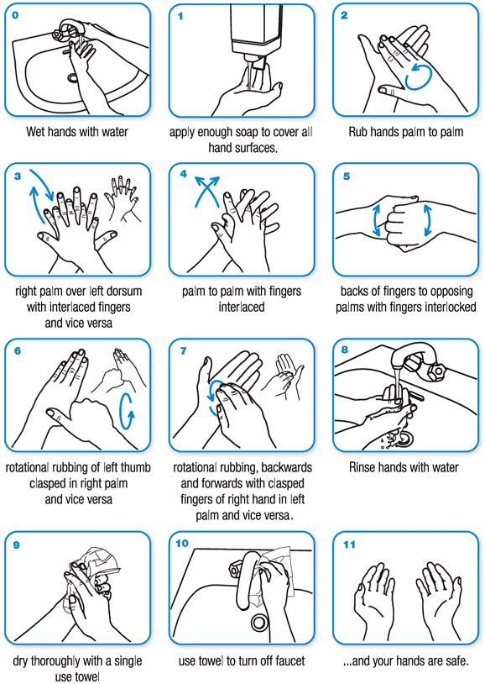
Clean hands protect against infection
Protect Yourself
● Clean your hands regularly
● Wash your hands with soap and water, and dry them thoroughly
● Use alcohol-based handrub if you don’t have immediate access to soap and water
How do I wash my hands properly?
Washing your hands properly takes about as long as singing “Happy Birthday” twice.

